**Linear Regression: Case Study**

For linear Regression case study, we take the “Hospital” dataset. This dataset is simulated hospital patients datasets of MATLAB. This dataset contains five predictors, hundred observation and low and high blood pressure. We apply linear regression on this dataset for the prediction of the blood pressure (both high and low) of the patients. For the optimization of the cost function we use gradient descent method. The complete codes are attached with this file.

Result:

Testing of hypothesis in MATLAB:

Taking inputs from keyword i.e., age, weight and smoker or not

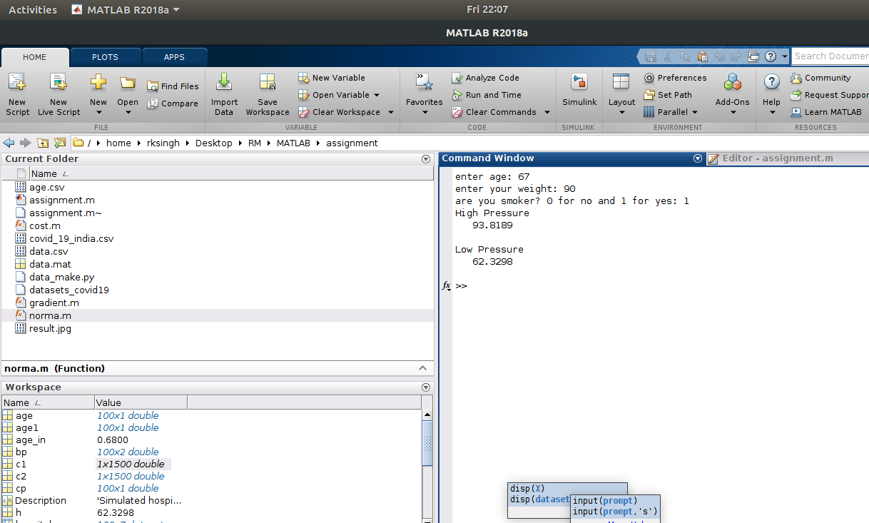

Fig. 1 Showing the test result for hypothesis

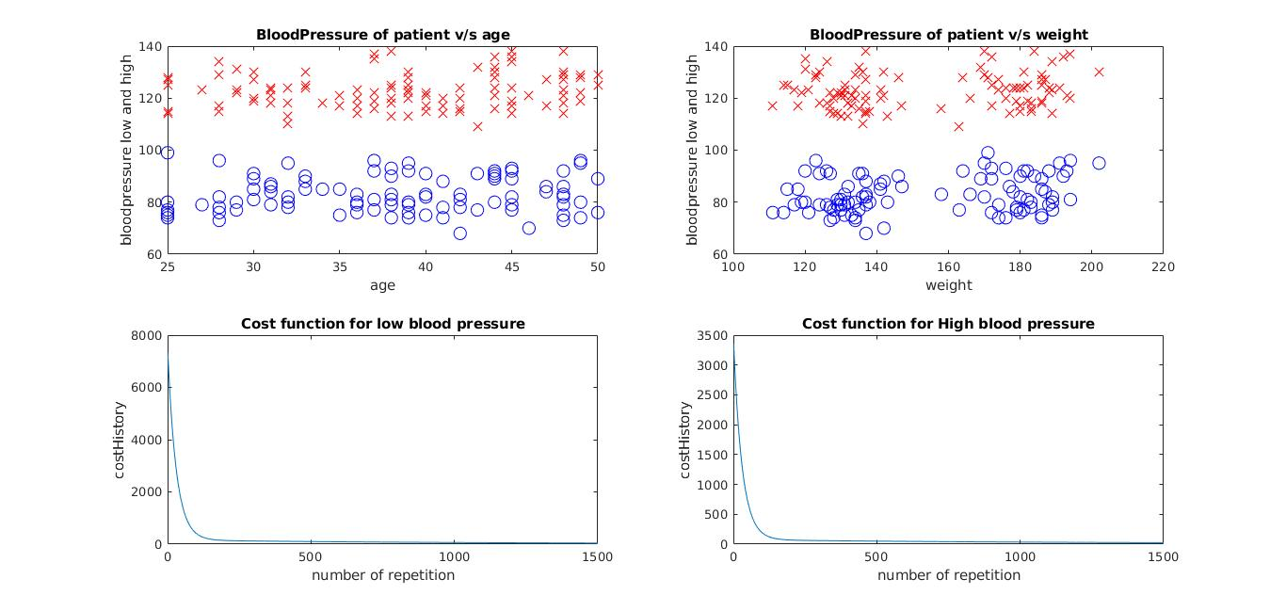

Fig.2 Result of MATLAB

For code please go to my github link: <https://github.com/rkresearcher/linearregression_gradientdescent.git>